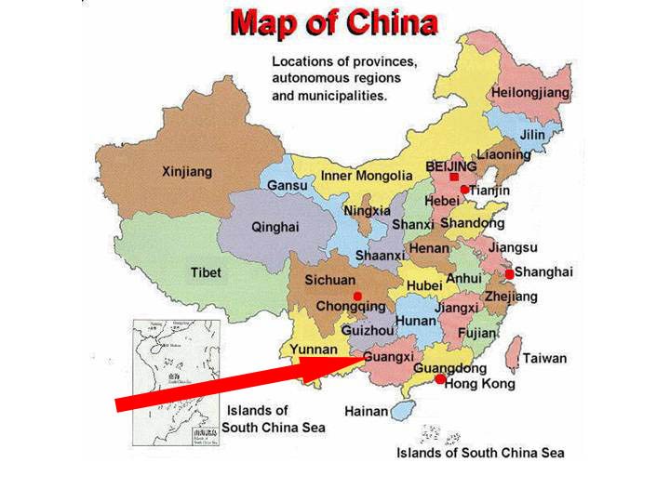

Figure 10: Map of China showing provinces with arrow pointing to the Lingyun area (near the “G” of “Guangxi”) in the far northwest of Guangxi Province, where our expedition was based”. [Map sourced from Clarke & Latella (2001).]

After provedoring for extra supplies, including purchase of ethanol from hardware stores and pharmacies for my cave fauna collections, then sending off our obligatory postcards to home and friends, we commenced our journey to Lingyun. Travelling from Guilin to Lingyun involved a long day on the road, stopping frequently to pay road tolls at regional, county or local town borders. 

Figure 11: “Guangxi 2000” expeditioners on the government bus for the 380km journey from Guilin to Nanning.
For the first half of the day, we were securely fastened in seat belts in a government bus (Figure 11) complete with a hostess, TV monitors, Chinese newspapers and bus lunch (canned soup and noodles, plus some dry salted fruit), travelling 380km southwest along major highways to Nanning (the capital of Guangxi Province). At the Nanning bus station, we transferred to small “protective” police escort vans for the remaining 355km distance: a 260km journey along varying road surfaces travelling northwest to Bose (Baise) and a further epic 95km drive north, along narrow often single lane winding roads through the cone karst hills to Lingyun (the county town of Lingyun County) situated beside the picturesque Chengbi River. We arrived at our government run hotel (reportedly a converted Red Army barracks base) late in the evening, where we were greeted by a barrage of TV and newspaper reporters, plus a small entourage of local government officials. Prior to actually getting into the field, we spent a few days being “greeted” and hosted by various local town, municipal and provincial officials including high ranking members of the Chinese Army and Communist Party, plus representatives of tourism or civil development agencies. On such occasions, our hosts insisted on banqueting us and “taking tea” (drinking green China tea) or having numerous rounds of bottled beer (usually not chilled) that invariably included a “ganbei” (dry glass toast) where you immediately gulp your drink down, then hold your glass upside down in front of your ganbei challenger (Figure 12). Fortunately, most of the Chinese beer is very weak (low alcohol)! Nonetheless, we soon started getting anxious about getting out to see and explore the surrounding cone karst.
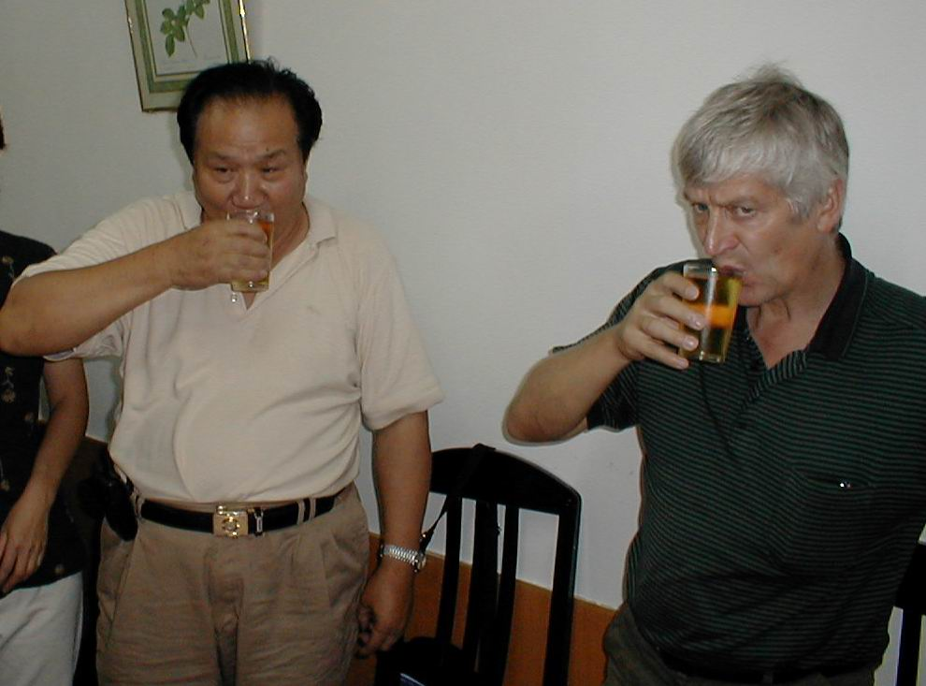

Figure 12: Prof. Zhu and Andy Eavis have
a “ganbei” toast with Guilin beer. Unless you say “suibian” (at your pleasure), you are expected to produce a “dry” (empty) glass following your “ganbei”.

Five days after our arrival in China, we were taken on a karst familiarisation tour to see cone karst areas beside the main north-south road, including the numerous depressions, dolines and collapses referred to as “natural hollows” by local officials. 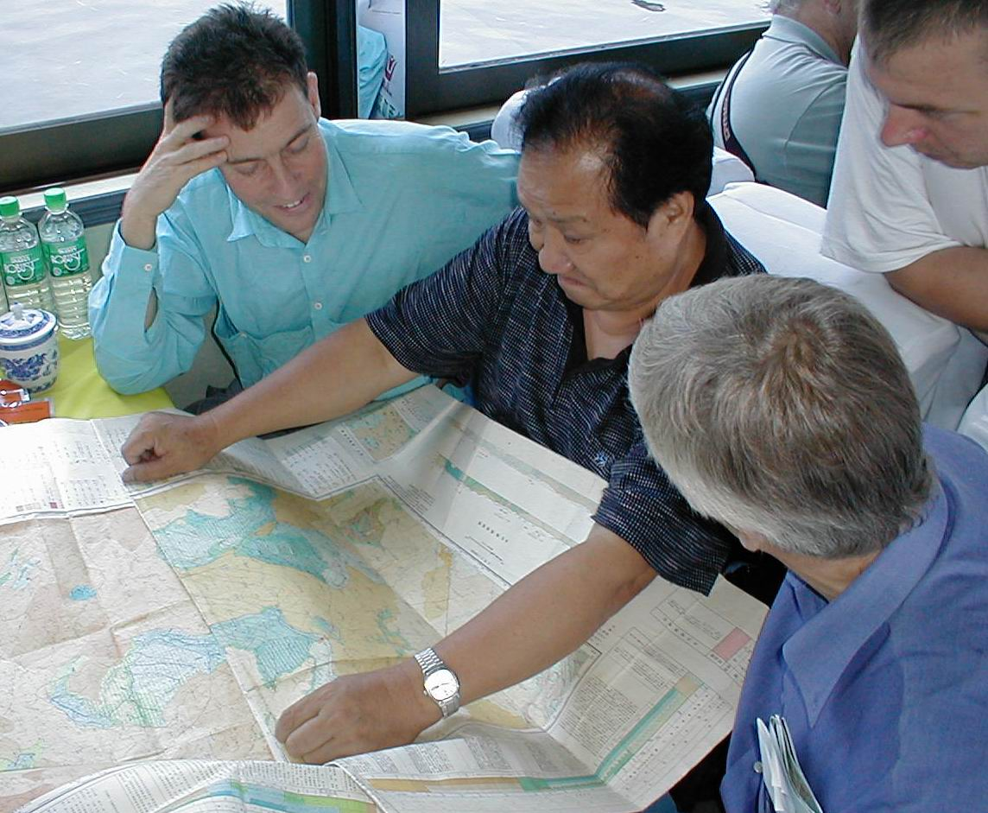

Figure 13: Ged Campion, Prof. Zhu and Andy Eavis perusing the geological map of the Lingyun karst area, where there are numerous unexplored “natural hollows”

Eventually, the following day when it started pouring with rain for the first time in a week, we started our karst exploration. Our expedition would spend just under three weeks exploring, surveying and documenting caves mainly in the cone karst north of Lingyun township (plus two brief days in the karst south of Lingyun). During the latter part of our time in NW Guangxi, the expedition party was divided into two groups, allowing half of us to continue cave exploration in Lingyun County, and enabling a small reconnaissance party to spend a week doing a preliminary investigation of the caves and the “natural hollows” further north in Lo-yeh Xian (Leye County) as a prelude to a future expedition planned for 2002.

Caves and karst development in SW China (and NW Guangxi Province)

The Peoples Republic of China has a vast area of carbonate rocks covering approximately 3.5million km² of its territory (Figure 14) and about a third of this is confirmed karst where carbonates, such as limestone, extend up to 3000metres in depth. Due to the purity of limestone in China, its high solubility and abundant rainfall in a range of climatic zones with rapid circulation of through flow waters, extensive subterranean hydrological systems with large caves and underground passages have developed from the effects of solution by aggressive natural waters charged with carbonic acid derived from plant humus and soils and sulphuric acid from the oxidation of in situ sulphides and solution of sulphates (Clarke, 2002). The structural geology of the carbonate rock areas in China is quite complex: joints, fissures and fractures - the structural features resulting from tectonic activity and crustal movement - have provided avenues for water movement, while fracture zones, folds, upheavals and subsidence act as boundaries controlling water movement and the development of separated or isolated hydrological systems. There is evidence for periods of multiple karstification with defined stages of karst development recorded in six provinces during the Cretaceous-Early Tertiary, Tertiary-Early Quaternary and present late Quaternary (Holocene) development (Clarke, 2002). The most intensive area of karst development in China is situated in three adjoining provinces in SW China: Guangxi, Guizhou and Yunnan where karst represents 28.9% (320,000km²) of the total land area of those provinces (Chen Xiaoping et. al., 1998).

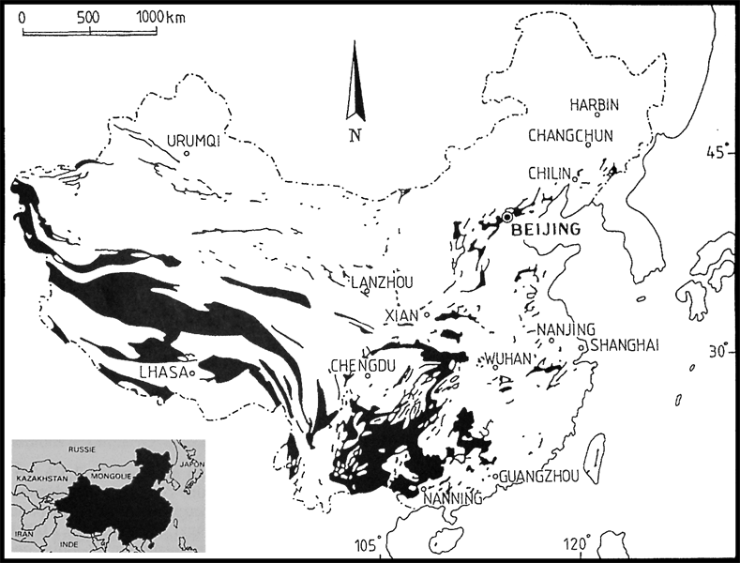

Figure 14: Distribution of carbonate rock areas in China. [Reproduced with permission from Chen Zhiping et. al. (2001) where it appeared on page 1763 of their manuscript on the cave fauna of China in Encyclopaedia Biospeleogica, Part III,. Map originally titled: "Les zones karstiques de Chine".]

In these three provinces (Guangxi, Guizhou and Yunnan), there are many forms of karst. The tower karst seen near Guilin (with occasional isolated pockets of cone karst) is the most prevalent large scale landform in the lowlands of southern China, where obelisk-like towers of limestone extend abruptly from the otherwise generally flat-floored lowland plains (Figure 15). As you travel further west and north, there is a predominance of peak cluster-depression karst which progressively develops as cone karst in the mountainous regions (Figures 16 and 19). This cone karst extends back (north and west) to the stony karst in eroded plateau regions that mainly form part of the inclined Yunnan-Guizhou (“Yungui”) plateau (Figure 17), where pockets of pinnacle karst predominate, such as the famed Shilin Stone Forest in Lunan County, east of Kunming in Yunnan (Figure 18). There are numerous associated landforms with all three of these karst forms, including the very impressive tiankengs found in cone karst areas. Described as a form of collapse doline, these tiankengs are massive cliff-walled collapse structures typically found in the more elevated cone karst areas of SW China, e.g., Dashiwei tiankeng in NW Guangxi Province (Figure 20) and Xiao Zhai Tiankeng near Xin Long in southern Chongqing Province.

